

* All Tribal members are protected from significant risks to human health and the environment where they live, learn and work;
* Efforts to reduce environmental risk are based on the best available scientific information;
* Federal laws protecting human health and the environment are enforced fairly and effectively;
* Environmental protection is an integral consideration in U.S. policies concerning natural resources, human health, economic growth, energy, transportation, agriculture, industry, and international trade, and these factors are similarly considered in establishing environmental policy;
* All parts of society – communities, individuals, businesses, and state, local and tribal governments – have access to accurate information sufficient to effectively participate in managing human health and environmental risks;
* Environmental protection contributes to making our communities and ecosystems diverse, sustainable and economically productive; and
* The United States plays a leadership role in working with other nations to protect the global environment.

Richard Leasure

Environmental Protection Program Director

PO Box 1153

Wagner, SD 57380

Phone: (605) 384-5003

Fax: (605) 384-5006

YST – ENVIRONMENTAL PROTECTION PROGRAM

**Winter Fire Safety**

*With propane costs skyrocketing this year, more and more people are depending on space heaters, wood stoves and kerosene heaters to get through these harsh winter months.* ***Please take every safety precaution necessary while using these types of heating tools.***

* Safety around heating equipment and appliances is an important first step in reducing the threat of fire. Keep children and loose clothing at a safe distance.
* **Use a yardstick to measure the distance between heating equipment and combustible material. Unless you have three feet of clearance, you are at risk.**
* Always turn off portable heating appliances when leaving home or retiring for the evening. Be sure the fire in the fireplace is out before going to bed.
* Install smoke detectors on every level of your home, including the basement, and test them monthly.
* If you smell gas in your home, contact your local utility company or qualified professional heating contractor and follow their advice.

**Candle Burning Safety Tips**

* Place candles on a secure surface in sturdy noncombustible holders that won’t tip over.
* Keep candles away from children and pets. Candles should be out of children’s reach.
* Keep candles away from combustible items such as curtains, books, and paper. **Remember the three foot rule!**
* Remember to extinguish candles when leaving the room or going to sleep. Never leave children or pets unattended in a room with a lit candle.
* Keep candles away from flammable liquids. Do not use a candle for light when fueling a kerosene heater or lantern.

**Home Heating Tips**

Environmental protection program’s purpose:

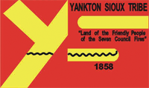

Delete text and place photo here.

*“Protecting the human health and environment”*

YST - ENVIRONMENTAL PROTECTION PROGRAM

**­\\\\\\\\\\\\**

Volume 1 issue 2

­

FEBRUARY 2014

­

***“Protecting the human health and environment.”***

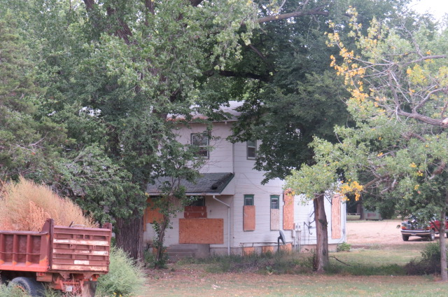

Through funding from the Environmental Protection Office, our Brownfields Program is able to provide financial and technical assistance to the Yankton Sioux community for Brownfields activities.

To date, there are two sites in the Marty community that have been identified as potential Brownfields sites:

* St. Katherine’s
* St. Joseph’s

And there is one that is considered a Targeted Brownfields Assessment (TBA) site.

* Marty Indian School Former Guest House

If you have any comments or concerns about these sites, please contact the Environmental office we would like to have input from the community!

Contact: Danielle Zephier, Brownfields Coordinator

Phone: (605) 3894-5003

The Marty Indian School Former Guest House.

The Environmental Protection Agency’s (EPA’s) Brownfields Program is built on four pillars:

* Protecting public health and the environment
* Promoting partnerships
* Strengthening the marketplace
* Sustaining reuse

The Program is designed to empower states, communities, tribe’s and other stakeholders in economic redevelopment to work together in a timely manner to prevent, assess, safely clean up, and sustainably reuse brownfields. A brown field is a property, the expansion, redevelopment, ore reuse of which may be complicated by the presence of a hazardous substance, pollutant, or contaminant. EPA’s Brownfields Program provides financial and technical assistance for brownfields activities through an approach based on those four pillars.

**BROWNFIELDS DEPARTMENT**

What is a brownfield?

Photo of a wall with peeling lead based paint.

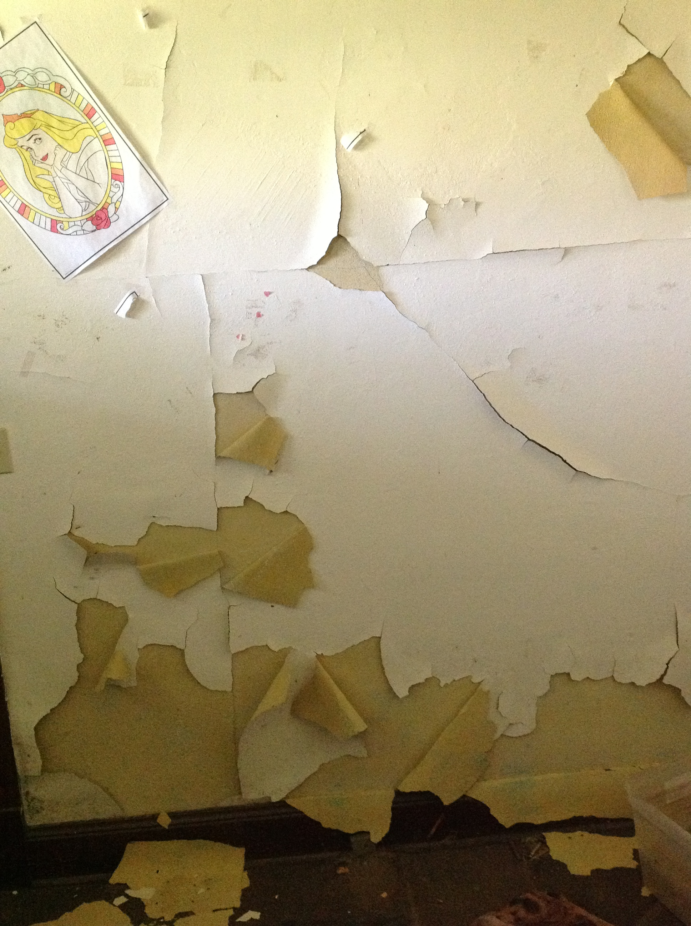

**TO EMPOWER TRIBE’S, COMMUNITIES, STATES AND OTHER STAKEHOLDERS IN WORKING TOGETHER TO PREVENT, ASSESS, SAFELY CLEAN UP, AND SUSTAINABLY REUSE BROWNFIELDS.**

FEBRUARY 2014

­

Volume 1 issue 2

­

***ANYONE can recycle through the Yankton Sioux Tribe Recycling Center****.*

Help recycle to protect the human health and environment.

Local businesses that utilize the YST Recycling Program:

* Buche Foods
* Wagner Gus Stop
* Lake Andes Gus Stop
* Indian Health Service
* Marty Indian School
* Marty Indian School Student Council
* YST Travel Plaza
* YST Tribal Programs
* Fort Randall Casino/Hotel

CONTACT: YST-EPP

Phone: (605) 384-5003

Fax: (605) 384-5006

yst recycling center

**INFORMATION TO REMEMBER**

* With the cold weather here, we ask that everyone please try to take care of your trash cans.
* During inclement weather, the Garbage Pick Up schedule may alter.
* Please try to keep dogs out of the garbage cans. If you need an extra can, stop by the Utilities office and fill out an application and an extra Garbage Can will be dropped off.

Pickup Schedule:

* Monday: Rural Solid Waste Pickup
* Tuesday: Lake Andes, Pickstown and Marty
* Wednesday: Wagner, Dante, Choteau Creek
* Friday: Landfill

If you need more information please contact the Utilities office:

Bryan Heth, Utility Program Manager

Phone: (605) 384-5003

Fax: (605) 384-5006

**yst utilities/solid waste department**

Here are some tips that will help you cut down on waste and boost your recycling skills:

* Purchase paper and other products for your home and office that are made with post-consumer recycled content and packaged in recyclable materials.
* Put collection bins in various places around your home and office to make recycling convenient.
* Reduce the environmental impacts of organic waste by composting food scraps.
* Bring your own reusable bags to local stores.
* Encourage tribal and local officials to consider incentives and more ambitious recycling initiatives.

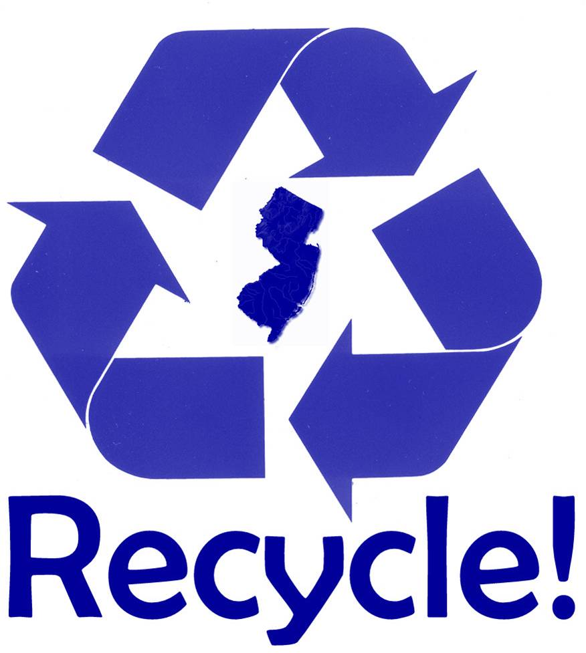

We recycle:

* Paper
* Cardboard
* Newspaper
* Plastic Bottles
* Metal Cans
* Aluminum Cans

.

*Help protect unci maka by participating in recycling!*

FEBRUARY 2014

­

Volume 1 issue 2

­

**“RECYCLE – The possibilities are endless!”**

­